**HACKATHON 3**

**DAY 3**

**API INTEGRATION AND DATA MIGRATION**

**Objective:**

The focus for Day 3 is integrating APIs and migrating data into Sanity CMS to build a functional marketplace backend.

**WHAT TO SUBMITTING:**

A report documention:

* API integration process
* Adjustments made to schemas
* Migration steps and tools used

Screenshots of:

* API calls
* Data successfully displayed in the frontend
* Code snippets for API integration and migration

Scripts.

1. **Setting up Environmental variables:**

First, create a .env.local file in my project.

Add these variables:

* NEXT_PUBLIC_SANITY_PROJECT_ID
* NEXT_PUBLIC_SANITY_DATASET
* SANITY_API_TOKEN

1. **Getting your sanity project id and API token:**

Project ID

* Login in to sanity.io
* Select your project
* Find the project ID in the dashboard

API Token

* Go to the sanity and select your project
* Go to the API tab
* Click add API Token under “Tokens”
* Name the Token and set permissions(choose “editor” or “developer” for full access)
* Copy the generated Token

Dataset:

Dataset will always be production

1. **Creating the Sanity Schema**

In Sanity/schemaTypes folder, Create a file called products.ts

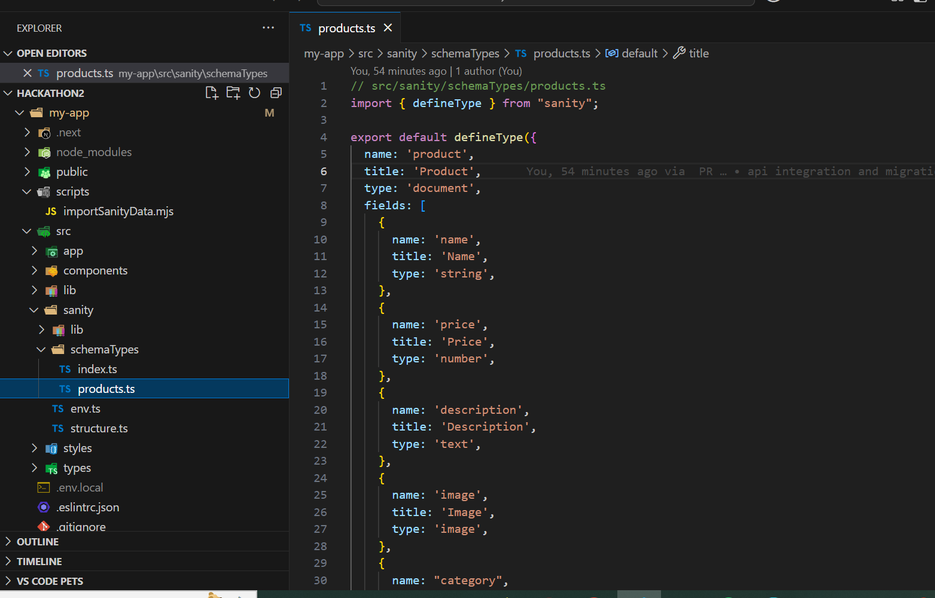

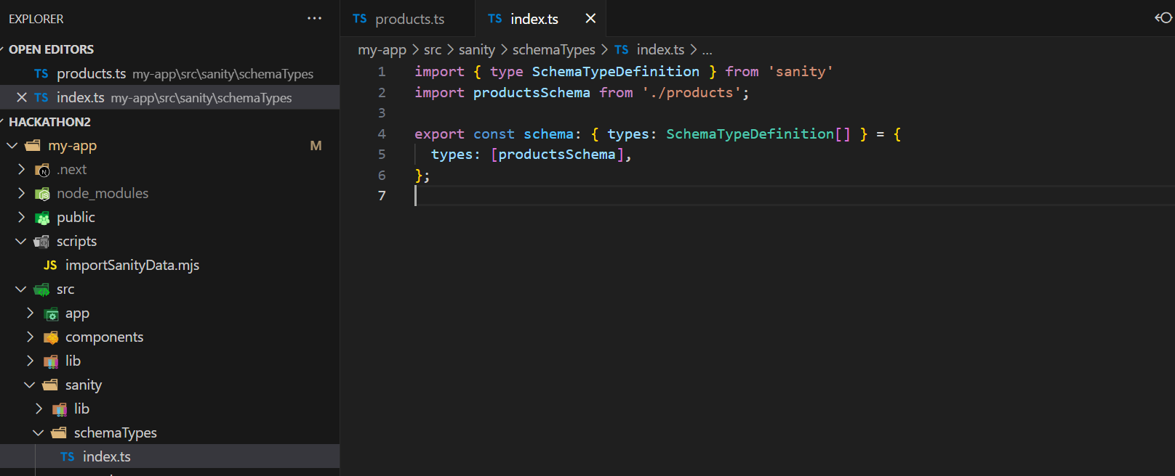

1. **Setting up the Data Import Scripts:**

Create a new file scripts/importSanityData.mjs in your project root.

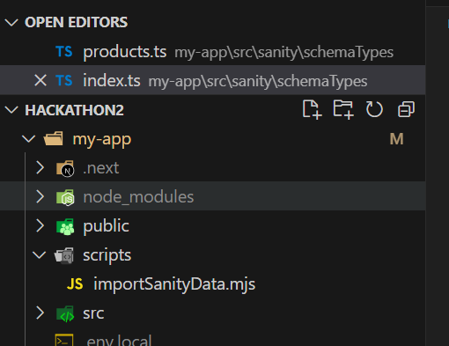

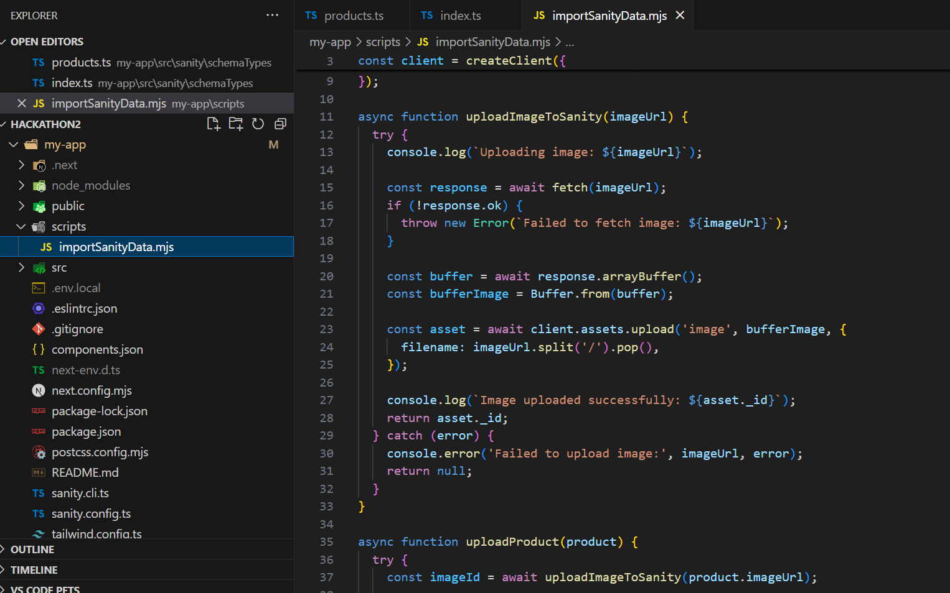

1. **Install the package:**

Run the following command in your terminal.

npm install @sanity/client axios dotenv

1. **Running the Migration Scripts:**

Add the following line into your package.json file to create a migration script:

“scripts”:{

“import-data”:”node scripts/importSanityData.mjs”

}

Alternatively,run following command into your terminal

npm run import-data

1. **Verifying Data Migration in Sanity:**

